SAVE THE DATE
Commemorating the 50th anniversary of Senator Robert F. Kennedy’s famous speech in Indianapolis on April 4, 1968, the night Dr. Martin Luther King Jr. was assassinated.

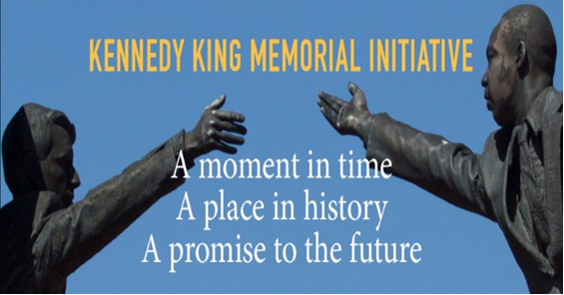

Join campus and city-wide commemorations of this historic event. IUPUI supports the Kennedy-King Memorial Initiative in events on April 4th at the Landmark for Peace Memorial. On April 5th, conversations continue at IUPUI on issues still relevant today.

Tuesday, April 3rd and Wednesday, April 4th – Sponsored by Kennedy King Memorial Initiative
This year’s celebration will feature Congressman, author, and civil rights pioneer John Lewis and Kerry Kennedy, president of Robert F. Kennedy Human Rights and daughter of RFK.
April 3 at 5:30 pm - “A Ripple of Hope” film viewing and panel discussion at Indiana Historical Society
April 4 at 10:30 am - “Reflection & Community Conversation” at the Landmark for Peace Memorial
April 4 at 5:00 pm - "Still We Reach" 50th anniversary commemoration ceremony at the Landmark for Peace Memorial
The Kennedy King Memorial Initiative is also sponsoring other events leading up to April 4th. For details, go to: http://kennedykingindy.org/the-50th-anniversary/

Shuttle Rides to “Landmark for Peace” Commemoration Ceremony, 5:00 p.m.
The IUPUI Division of Student Affairs will provide shuttle rides to and from the Landmark for Peace Memorial at 17th Street and Broadway, starting at 3:00 p.m., for students to participate in this historic event. Students will have the opportunity to view a short documentary about Kennedy’s speech, “Awful Grace,” before boarding the shuttle to the site. Details to follow.

SAVE THE DATE
Thursday, April 5th – IUPUI Civil Discourse Symposium & Diversity Speaker’s Series

Keynote Featuring Kimberle’ Crenshaw
Distinguished Professor of Law, UCLA School of Law
“The Urgency of Intersectionality”
Campus Center Theater, 6:00 p.m.

Dr. Crenshaw teaches Civil Rights and other courses in critical race studies and constitutional law. Her primary scholarly interests center around race and the law, and she was a founder and has been a leader in the intellectual movement called Critical Race Theory. She is co-author of Say Her Name: Resisting Police Brutality Against Black Women. Co-sponsors: IUPUI Division of Diversity, Equity and Inclusion and the Indiana Civil Rights Commission.

Other April 5th events:
9:00 – 10:00 a.m. – Fifty Years after Reverend Martin Luther King Jr.’s Assassination: How is America of Today Different from What We Thought it Would Be Fifty Years Ago? Campus Center, Room CE 307 - Speaker: Dr. Kevin D. Brown, Richard S. Melvin Professor of Law, IU Maurer School of Law. With respect to African-Americans, America has changed significantly from what it was when Reverend King was taken from us. But many of these major changes could not have been predicted from what we knew back in 1968. We will journey back to the situation of the African-American Community in 1968, imagine what we thought 50 years of change would bring from that vantage point, and compare where we are today to where we thought we would have been 50 years later. Sponsored by: IUPUI Equal Opportunity Council.

Noon to 1:15 p.m. –Critical Conversation: K(no)w Voice, K(no)w Power: Reflections on Martin Luther King, Jr. and Robert F. Kennedy, Campus Center, Room CE 305 – Reflecting on Kennedy’s speech, this interactive activity will explore the power of words and conversation to persuade and build empathy. Co-Facilitators: Dan Griffith, Director of Conflict Resolution and Dialogue Programs, IUPUI Division of Diversity, Equity and Inclusion; Kim White-Mills, Associate Professor, Communication Studies; and Mel Wininger, Senior Lecturer in English. This event was originally presented at the Spirit & Place Festival, co-sponsored by IUPUI Office of Intercultural Literacy, Capacity and Engagement, Indiana Historical Society, Kennedy King Memorial Initiative, and Desmond Tutu Center.
4:00 to 5:00 p.m. – Dr. Kimberle’ Crenshaw will engage in informal conversation with law students and alumni at the IU Robert H. McKinney School of Law.
Related Event: Tuesday, April 3, Noon to 2:00 p.m. – Campus Center Atrium – Reader’s Theater of April 4, 1968: Before We Forgot How to Dream. Written by James Still, IRT Playwright-in-Residence, this play provides an intimate look at an Indiana family’s collision with history when Bobby Kennedy delivered his powerful speech in Indianapolis on the night of Martin Luther King Jr.’s assassination. IUPUI students will read portions of this play to provide students perspective and engender interest in events on April 4 and 5. Co-directed by: Jan DeWester, Senior Lecturer in Communication Studies and Director, Theatre and Performance Certificate, and Courtney Mohler, Assistant Professor, Theatre Program, Butler University.

